A Project Report

On

Exo-Suit

**Requirements Elicitation**

**and Requirements Analysis**

**Feb 26, 2019**

**Nitesh Manadhar**

**Sahaj Shakya**

**Table of content**

|  |  |
| --- | --- |
| **Topic** | **Page No:** |
| A. Requirement Elicitation | 1-13 |
| 1. **Introduction** | 1 |
| 1.1 Purpose of the system | 1 |
| 1.2 Scope of the system | 1 |
| 1.3 Objectives and success criteria of the project | 2 |
| 1.4 Definitions, acronyms, and abbreviations | 2 |
| 1.5 References | 2 |
| 1.6 Overview | 3 |
| 1. **Current system** | 4 |
| 2.1Brief of each workflows | 4 |
| 2.2 Interaction among objects | 4 |
| 1. **Proposed system** | 4-12 |
| 3.1 Overview | 4 |
| 3.2 Actors | 5 |
| 3.3 Scenarios | 6 |
| 3.4 Functional requirements | 6-10 |
| 3.4.1 Use cases | 6 |
| 3.4.2 Refined use cases | 7 |
| 3.4.3 Relationship between actors and use cases | 8 |
| 3.4.4 Initial analysis objects | 9-10 |
| 3.5 Non-functional requirements | 10-12 |
| Quantifiable measured used | 10 |
| Implementation requirements | 10 |
| Interface requirements | 10 |
| Operation requirements | 10 |
| Package requirements | 11 |
| Behavioral requirements and properties | 12 |
| 1. **Glossary** | 13 |
|  |  |
| **B. Requirements Analysis** | 14-18 |
| **3.6 System Models** | 14 |
| 3.6.1 Use case model | 14 |
| 3.6.2 Object model | 14- |
| 3.6.2.1 Data dictionary of objects | 14-16 |
| 3.6.2.2 Class diagrams | 17 |

|  |  |
| --- | --- |
| 3.6.2.3 Interaction among objects | 18 |
| **3.6.3 Dynamic models** | 19-22 |
| 3.6.3.1 Sequence diagram  3.6.3.2 State machine diagram | 19  20 |
| **3.6.4 User interface with navigational paths and screen mock-ups** | 21 |

1. **Introduction:**

Exo-Suit is a wearable mobile machine that is powered by a system of electric motors, hydraulics and combination of computing technologies that allow for limb movement with increased strength and endurance. The core component is an EMG signal wave from the user arm. EMG stands for electromyography that is a technique for evaluating and recording the electrical activity produced by skeletal muscles.

* 1. **Purpose of the system**

The purpose of the system can be used on the application of Military, Medical and Civilian purposes.

* Generally, Military solders has to carry lot of heavy armory and travel a large amount of distances maintain the same rate. The system decreases fatigue and increased productivity while unloading supplies or enabling a [soldier](https://en.wikipedia.org/wiki/Soldier) to carry heavy objects (40–300 kg) while running or climbing stairs while lowering their metabolic rate or maintaining the same rate with more carry capacity.
* Similarly, as people grow older their joints gets weaker and would have hard time performing daily tasks. Also, patients suffering from damage spinal injuries are impaired for life. Exo suit with its muscles sensing technology can reduce the muscle power delivered by the system but calculating the average power delivery and also maintains a constant posture.
* lots of people (firefighter, industrial workers) reply on their physical strength to perform their work task. As human being can be subjective to feeling of tiredness and fatigue, the system can be used to survive dangerous environments providing super human strength
  1. **Scope of the system**

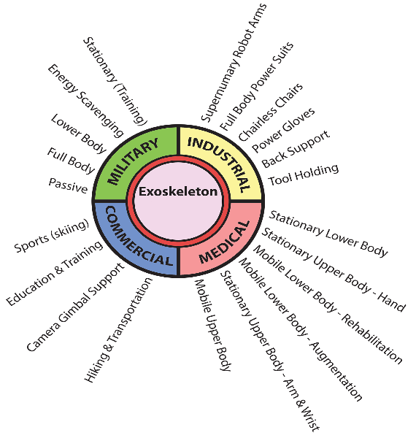The Scope of the System can be categories into four different category

1. Military
2. Industrial
3. Medical
4. Commercial

*Fig 1.2: Scope of the system*

* 1. **Objectives and success criteria of the project**

The main objectives are:

* To reduce human effort while lifting heavy weights.
* To provide support for SCI such that they would be able to walk with muscles sensing technology
* To reduce time and effort.
* To utilize biomedical signals in Robotics.
  1. **Definitions, and abbreviations**

**Definitions:**

|  |  |
| --- | --- |
| 1. Exo-Suit: | wearable devices that are placed on the user’s body and act as amplifiers that augment, reinforce or restore human performance |
| 1. Electromyography: | technique for evaluating and recording the electrical activity |

**Abbreviations:**

1. **EMG:** Electromyography
2. **SCI:** Spinal Cord Injury
   1. **References**

[1] C. J. De Luca, “The Use of Surface Electromyography in Biomechanics,” J. Appl. Biomechan., vol. 13, pp. 135–163, 1997.

[2] R.A.D.M.P.Ranwaka1, T. J. D. R. Perera, J. Adhuran, C. U. Samarakoon, “Microcontroller Based Robot Arm with Three Dimensional Reach”, South Asian Institute of Technology and Medicine, Sri Lanka.

[3] Das K. Santos “Robotic Arm Control through Human Arm Movement Using Accelerometers”, National Institute of Technology: Rourkela.

[4] Shital B. Sonone, G. D. Dalvi, “Real Time Control of Robotic Arm Using Electromyogram (EMG) Signals”, Electronics & Telecommunication Engineering, P. R. Pote (Patil) Welfare & Education Trust’s College of Engineering & Management: Amravati, January 2016.

[5] C.J. De Luca, M. Knaflitz, “Surface Electromyography: What's New?” Torino, Italy, 1992.

[6] C.J. De Luca, B. Mambrito, “Voluntary Control of Motor Units in Human Antagonist Muscles: Reciprocal Activation and Co-activation” Journal of Neurophysiology, 1987.

[7] Dr. Roberto Merletti, “Standards for Reporting EMG Data”, Politecnico di Torino, Italy.

* 1. **Overview**

The basic concept is to use a low dimensional input derived from electromyography data to control a suit. First we verify the system that is used to record the human body signals is adaptable to other forms of bio signal input; in particular, direct connection to a human brain via Muscle movement via Electromyography (EMG).

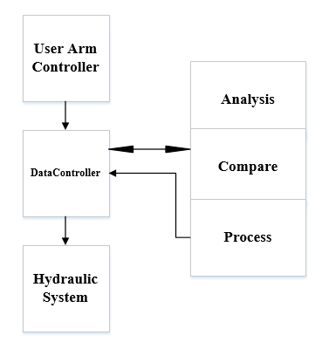

*Fig 1.6: Basic Overview*

The User arm is basically the input for the overall system. First the user arm controller makes sure that the EMG sensors are on placed or not. The actor can authenticate the system by using finger print sensor to load up the data on the system. After the user arm controller is activated, it fetches the data to the software that performs various analysis. The data controller acts as a bridge between the user arm controller, hydraulics system and the software analysis part.

First the data controller makes that serial data is being fetched out from the user arm system or not. Then, the data is passed to the software analysis part. The software performs various analysis (such as FFT, wavelet analysis, window analysis) to figure out which frequency of the signal gets activated. By mapping the frequencies, it could figure out which particular muscles groups are activated and evaluate the power factor that needs to be amplified. The analyzed data is compared to the previous stored process data to speed up the processing. If the data is not found on Database, then the analyzed data is processed to a micro controller readable data so that the hydraulic system could understand. Finally, the DataController actor parses that converted data for the required hydraulic movements. In this way, DataController carried out two parallel processes to mitigate the data between the systems.

1. **Current System**
   1. **Workflow**

On current system, the user has to lift the load by themselves. They have to produce the exact force to lift the weight. Similarly, for military they also have to carry the ammunition without decreasing their rate of work. Due to heavy load, their muscles and postures may get damaged.

Our system plans to reduce the amount of force and power by 80%.

* 1. **Interaction between Workflow**

Particularly, for this projects there are two actors involved: EMGInput and HydraulicControl. The EMGInput acts as input for the system whereas Hydraulic arm replicates the user arm movements and the DataController bridges the data between arm and the system. The DataController sends the data to EmgAnaysis object that performs various analysis to indicate which particular muscle group is activated and find out the power factor needed to be amplified. EmgStoreCompare object compares the EmgAnalyzed data to the stored signal, weather if the pattern matches to the stored data or not. If not in Database, then the EmgProcess Object learns pattern of the signal and updates the database as well as also convert the processed data object to the datatype required for motor movements. Finally, the DataController actor parses that converted data for the required hydraulic movements. In this way DataController carried out two parallel processes to mitigate the data between the systems. The Hydraulic arm send a reply back signal that the operation has been performed and parallel process of DataController has been terminated.

1. **Proposed System**
   1. **Overview**



*Fig 3.1 Overview*

|  |  |  |  |
| --- | --- | --- | --- |
| Step 1: | Identify EMGInput Actor using Bio Metric Sensor (Finger print). | | |
| Step 2: | Make sure electrodes are placed on correct positions. | | |
| Step 3: | Measure the flex, muscle contraction and force of the actor and convert to voltage level | | |
| Step 4: | Convert the analog signal to digital using ADC making sure that Fs>F. | | |
| Step 5: | As soon as serial data arrives, DataController samples the data. | | |
|  | EmgAnalyze object analyses the data (FFT, Wavelet transformation, Power and Energy Spectrum to determine which muscle group is activated and how10 much power should be amplified. | | |
| Step 6: | EmgStoreandCompare object compares the EmgAnalyze data if the pattern matches to the stored data. | | |
| Step 7: | Step A: | If not in Database: | |
|  |  |  | EMGProcess object learns the pattern and store it in the database based on the rising curve values and its voltage level |
|  | Step B: | else: |  |
|  |  |  | EmgProcess object convert the EMGAnalyse object data to required hydraulic motor movement data to replicate the muscles movement of the UserArm actor. |
| Step 8: | Fetch the G code data to the Hydraulic System | | |
| Step 9: | Send a reply back signal that the operation has been performed. | | |

* 1. **Identify Actors**

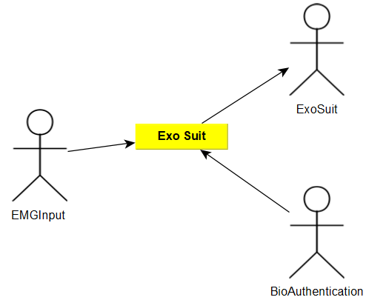

*Fig 3.2 Actors*

The actors for the systems are EMGInput, ExoSuit, and BioAuthentication.

* 1. **Scenarios**

|  |  |
| --- | --- |
| *Scenario name* | AnalyzeEmg |
| *Participating actor instances* | personarm: EMGInput, suit:Exosuit |
| *Flow of events* | 1. personarm, is the main source of input for the system |
|  | 1. personarm authenticates into the system to power it up |
|  | 1. personarm generates the required force to fetch the data to the system. |
|  | 1. The system checks whether the data arrives to system or not. |
|  | 1. The system loads the data in a form an array form. |
|  | 1. The system perform an filtration process to remove the unnecessary signals and noises. |
|  | 1. The system then perform an FFT on the filtered signal to determine the frequency response of the signal. |
|  | 1. In case, of a very large and fast moving data, the systems divides the filtered signals to equal windows to perform window analysis. |
|  | 1. The system then calculates the power of the respective frequency to evaluate the increasing power factor to analyze the load on user. |
| *Entry Condition* | * The serial data needs to be available to the system. |
| *Exit Condition* | * The ADC (Analog to Digital Converter) has to send an interrupt to close the serial data. * The power factor of the signal is calculated and the raw data remains unchanged. |

*Table 3.3: Scenarios*

* 1. **Functional requirements**

1. **Use Case**

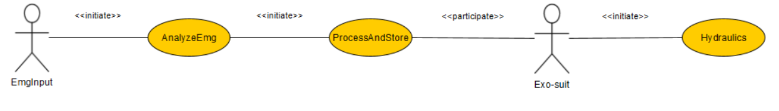

*Fig 3.4.A: Use Case*

1. **Refined Use Case**

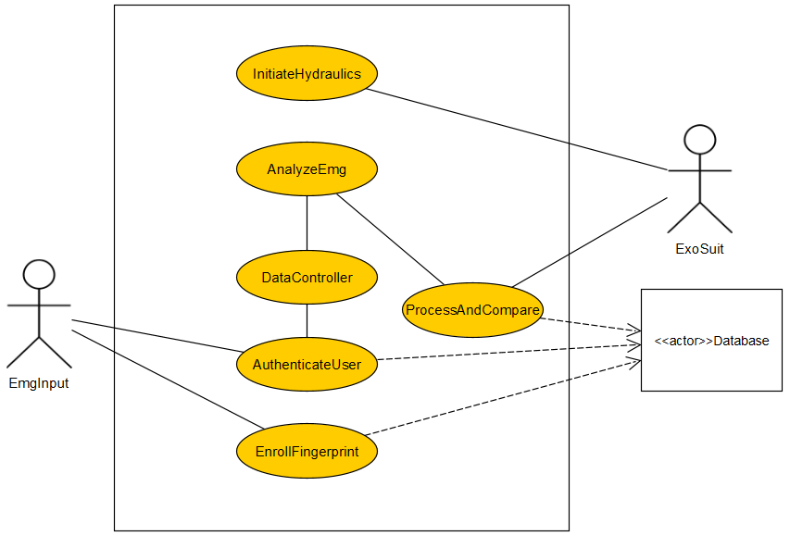

*Fig 3.4.B: Refined Use Case*

|  |  |  |
| --- | --- | --- |
| *Scenario name* | AuthenticateUser | |
| *Participating actor instances* | user: EMGInput, sensor: BioAuthentication | |
| *Flow of events* | 1. The user provided their fingerprint on the sensor to authenticate into the suit. | |
|  |  | 1. Sensor sends the fingerprinted data to the system for verification. |
|  |  | 1. The system send the user details providing that the authentication is correct. |
|  | 1. The user verifies the data provided by the system | |
|  |  | 1. Sensor provides the required data for starting the suit. |
| *Entry Condition* | * The EMG Electrode has to be placed on the users arm. | |
|  | * The sensor should have sufficient power. | |
| *Exit Condition* | * Sensor verifies the authenticated data for login. | |
|  | * User verifies their login data. | |

*Table 3.3.B: Scenarios*

1. **Relationship between Actors and Use case**

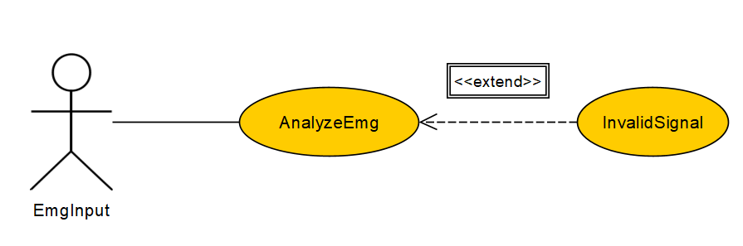

*Fig 3.4.C1: Extend Relationship*

|  |  |
| --- | --- |
| AnalyzeEmg(include relationship) | AnalyzeEmg(exclude relationship) |
| 1. …….. | 1. |
| 1. …….. | 2. |
| 1. …….. | 3. |
| 1. The system checks whether the data   arrives to system or not.  *If the connection is down, then the*  ***invalidsignal*** *use case is used.* | 4. The system checks whether the data  arrives to system or not. |
| 1. If the connection is still down, then the user checks the connection of all serial and sensor connections.   *If the connection is down, then the*  ***invalidsignal*** *use case is used.* | 5. The system loads the data in a form an array form. |
| InvalidSignal(include relationship) | InvalidSignal(exclude relationship) |
|  | *The* ***InvalidSignal*** *use case extends any use case in which the communication between the* ***user*** *and the* ***system*** *can be lost.* |
| 1. The **user** is notified that the serial data is missing and provides an notification about missing connection. | 1. The **user** is notified that the serial data is missing and provides an notification about missing connection. |
| 1. The users is logged but the system and recovered when the connections is reestablished. | 1. The users is logged but the system and recovered when the connections is reestablished. |
| 1. The user resend the data. | 1. The user resend the data. |

*Table 3.3.C: Relationship between use case and actors*

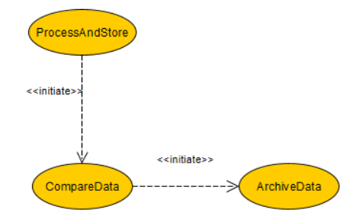

*Fig 3.4.C2: initiate Relationship*

1. **Initial Analysis Object**

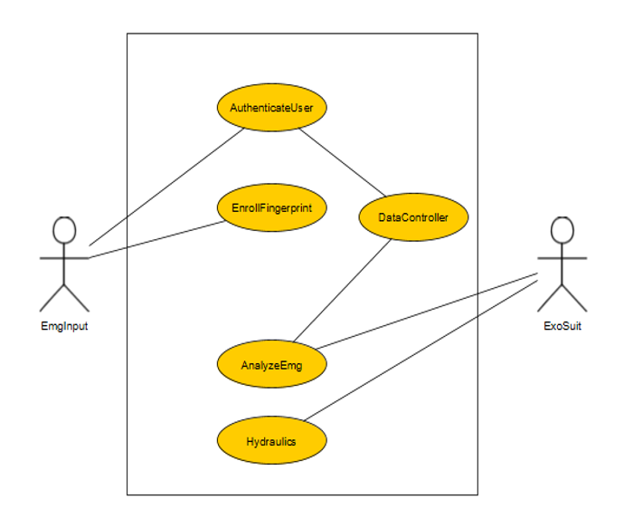

*Fig 3.4.D: initial Analysis Object*

* **EmgInput**: User arm which gives the needed EMG signals through the electrodes attached in it.
* **AnalyzeEmg**: It filters the EMG signals received from the EmgIput and analyze the needed power factors for processing.
* **ProcessAndStore**: This checks the processed signal and compares it if it is already in the archive or is a new signal pattern.
* **Exosuit**: The exosuit utilizes the processed signals and reads it to manipulate the hydraulic motors movements based on EmgInput value.
* **InitiateHydraulics**: This makes the suits movements based on the pattern received from the exosuit.
  1. **Non Functional requirements**

1. **Quantifiable measured:**

|  |  |
| --- | --- |
| Category | Non Functional Requirement |
| Usability | * User should not have access to the system without the authentication to the system. |
| Reliability | * When the system crashed, the hydraulic system should store to the previous state. * When there is connection error, the user should be notified in form f vibrations. |
| Performance | * There should not be delay more than 1000 milli-second between the user interaction and the suit. * The suit should only utilize user’s 20% force. |
| Supportability | * The user should be adjust the new electrodes point and its associated hydraulic moments for more muscles utilizations. |
| Implementation | * The user should install python to operate the application software * The software should be run on any operating system with required dependencies installed. * Administration task (Finger print data, users data) could only be accessible to the admin user. |
| Operation | * The client should not be able to spend more advertisement money than a fixed limit agreed. * The client should not change/upgrade the system without permissions. |
| Legal | * The user’s finger print data should be highly protected. * The client should be contracted with legal insurances of the user as required by local law. |

*Table 3.5.A Quantifiable measure*

1. **Package requirements**

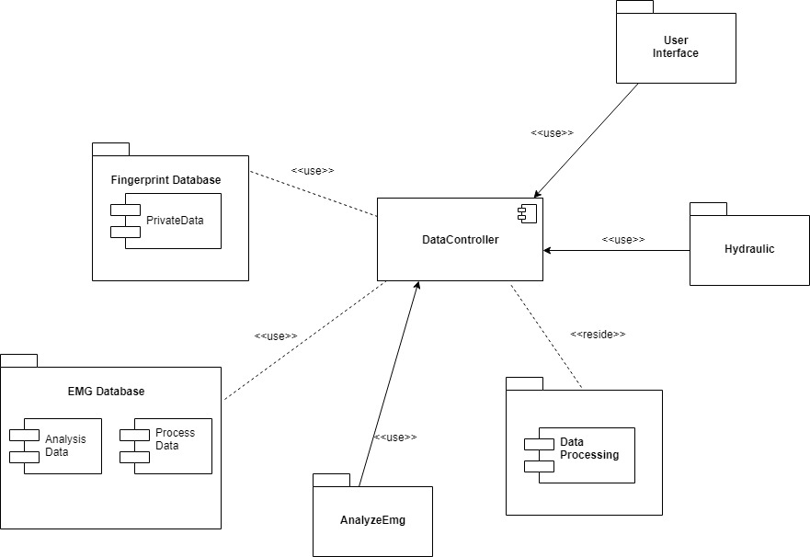

*Fig 3.5.B: Package Diagram*

1. **Behavioral requirements**

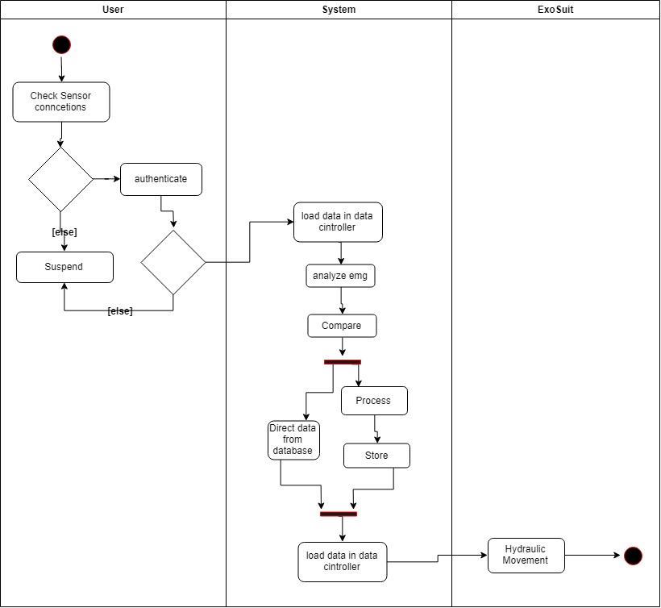

*Fig 3.5.F: Activity Diagram with object nodes*

1. **Glossary**
2. ADC: system that converts an analog signal into a digital signal.
3. Electrodes:  conductor through which electricity enters or leaves an object, substance, or region.
4. Electromyography: the recording of the electrical activity of muscle tissue, or its representation as a visual display or audible signal, using electrodes attached to the skin or inserted into the muscle.
5. Hydraulic: technology involving the mechanical properties and use of liquids.
6. Spinal Cord: long, thin, tubular structure made up of nervous tissue, that extends from the medulla oblongata in the brainstem to the lumbar region of the vertebral column

**B. Requirements Analysis**

**3.6 System Models**

**3.6.1 Use case model**



*Fig: 3.6.1 Use case model*

**3.6.2 Object model**

**3.6.2.1.I Identifying Boundary Objects**

|  |  |
| --- | --- |
| **Boundary Object** | **Definition** |
| **AuthenticationTouch** | Mechanism used by the **User** to gain inside the system. |
| **AuthenticationRequest** | Notice received by the **DataController** for requesting access. |
| **AuthenticationReply** | Notice received by the **User** indicating weather the user has been provided access to the system or not. |
| **AppltyFilter** | Filters out the unnecessary and noisy data from the received serial data. |
| **PerfomFFT** | Perfom fast fourier transform on the filtered data to find out the required frequency. |
| **InvalidData** | Sends back data back to **DataController** if data is not valid |
| **ProcessData** | Process the data to Gcode which motor could understand. |

*Table: 3.6.1.I Boundary Object*

3.6.2.1.II Identifying Control Objects

|  |  |
| --- | --- |
| **Control Object** | **Definition** |
| **SerialDataControl** | Indicates the flow of serial data from the U**ser** to the **DataController**. |
| **CompareAuthControl** | Compare authenticated data of **user** with store data on database. |
| **PowerSpectrumControl** | Perform the power spectrum analysis to calcite the power factor the **user** at the required frequency. |
| **CompareDataControl** | Compare the data between the **user** info and serial input with the data stored on the data base |
| **ServoControl** | Controls the servo motor for hydraulic fluid moment to control the **Exosuit.** |

*Table: 3.6.1.II Control Object*

3.6.2.1.III Identifying Entity Objects

|  |  |  |
| --- | --- | --- |
| **Entity Object** | **Attributes and associations** | **Definition** |
| **User** | * Id * Name | An user represent the person/ part of muscle from whom the data is being taken and wear the suit. |
| **ExoSuit** | * Model * Name * Motor | Actor that represent the suit which used the processed data to control the suit based on various scenarios |
| **DataController** | * SerialIn * SerialOut * AnalogRead * AnalogWrite | Represent the data flow from **user** to the analysis program and program to the **suit** |

*Table: 3.6.1.III Entity Object*

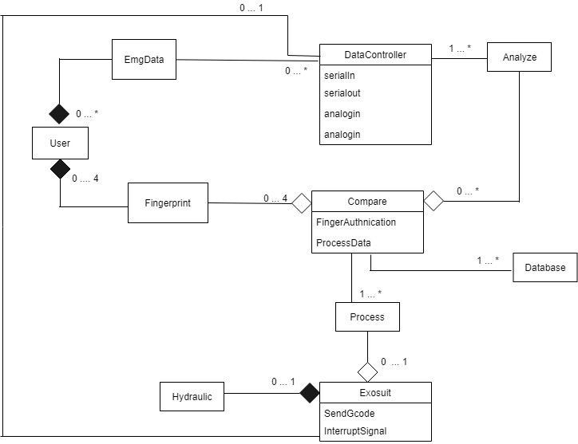

*Fig: 3.6.2. Object Diagram with link and aggregation*

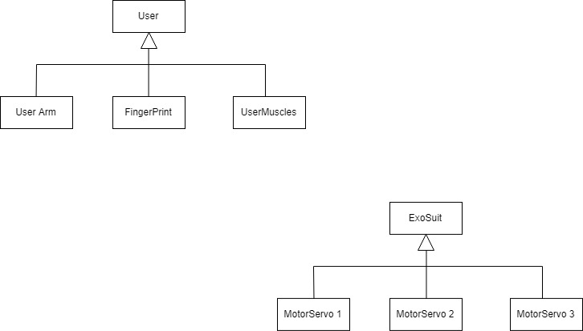

*Fig: 3.6.2.b Inheritance Diagram*

3.6.2.2 Class diagrams

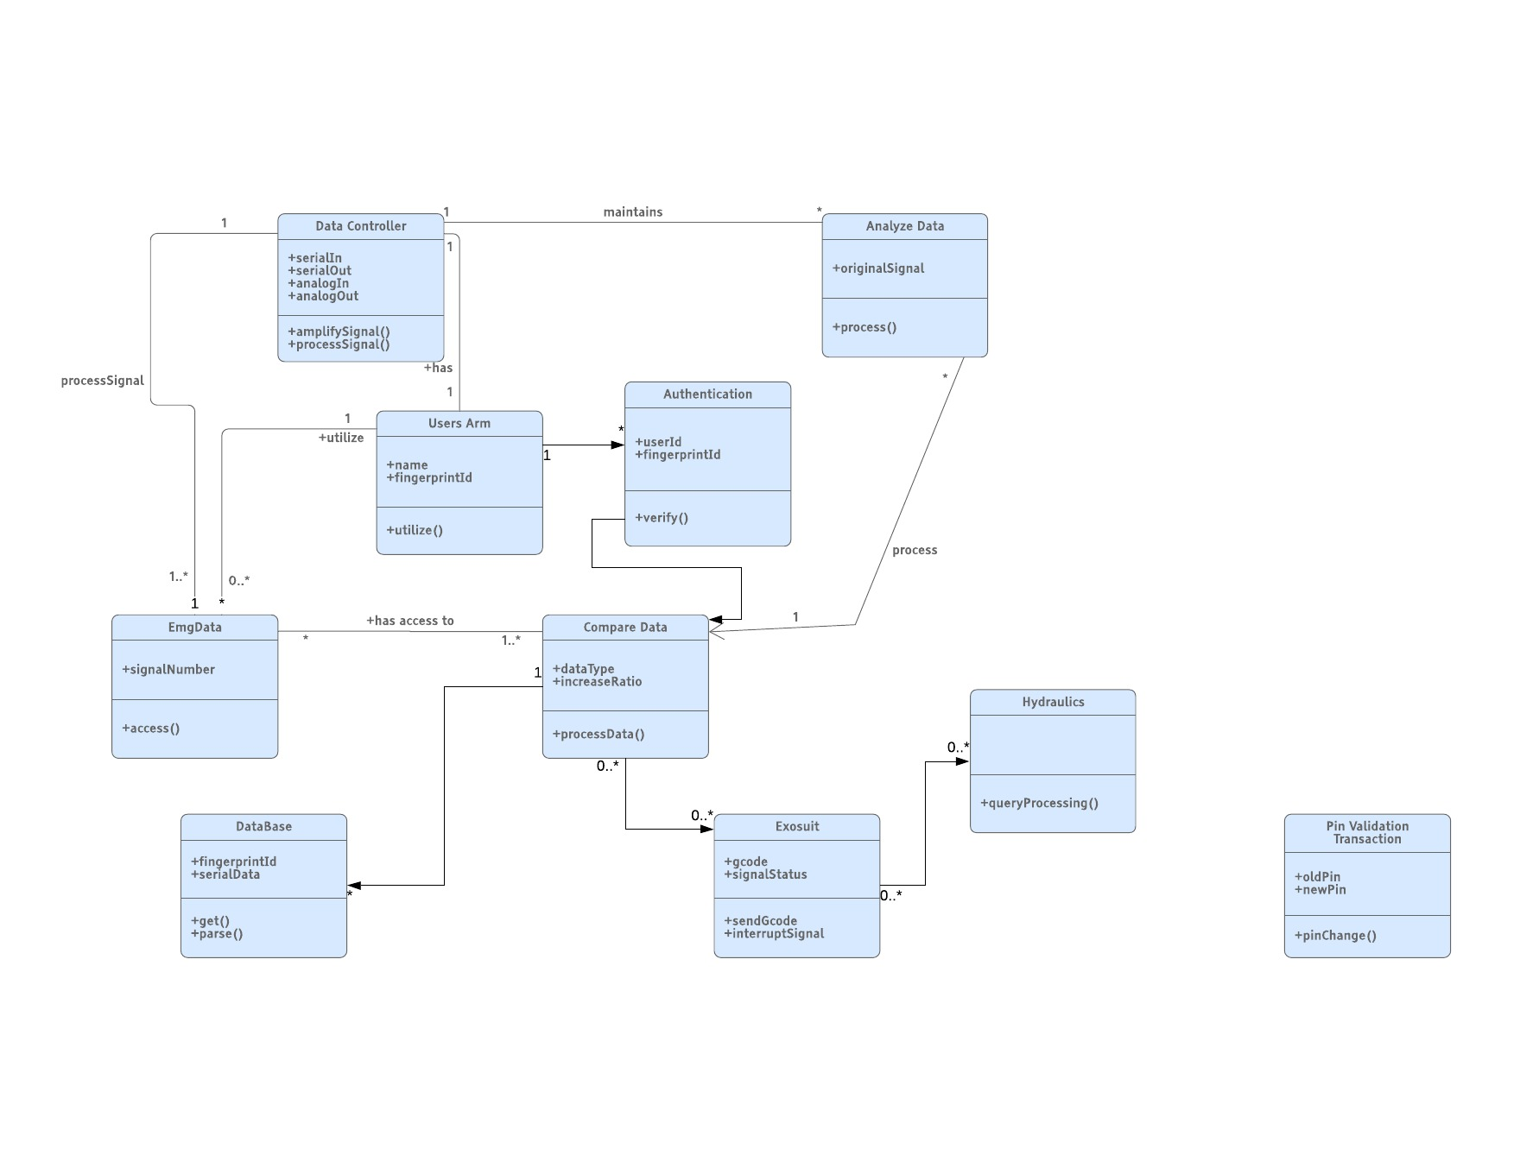

*Fig: 3.6.2.2 Class Diagram*

3.6.2.3 Interaction among objects

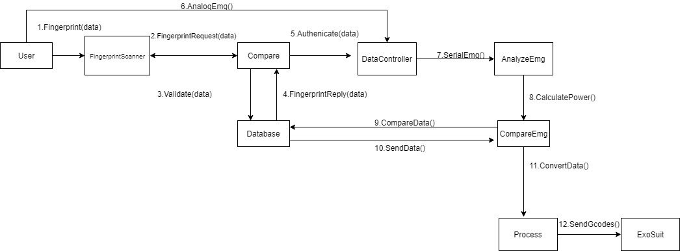

*Fig3.6.2.3.1: Sequence Diagram*

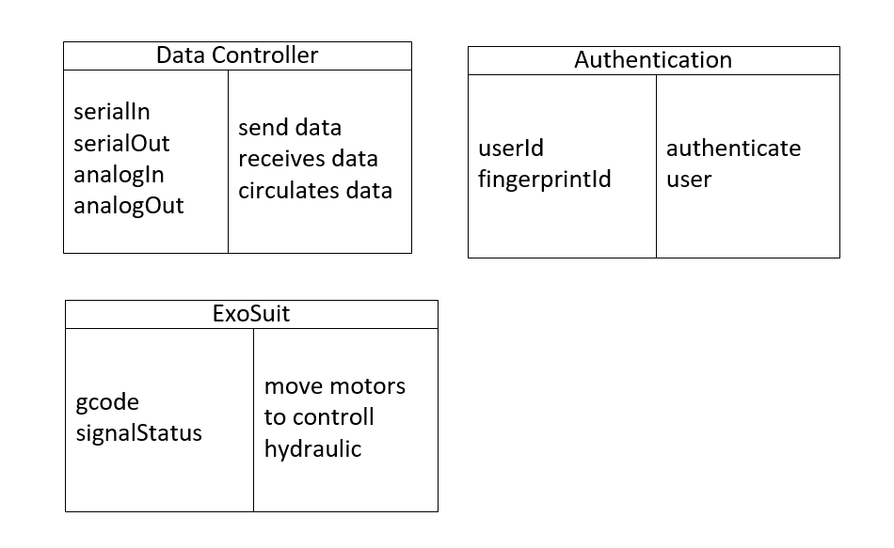

*Fig3.6.2.3.2: CRC Diagram*

**3.6.3 Dynamic models**

**3.6.3.1 Sequence diagram**

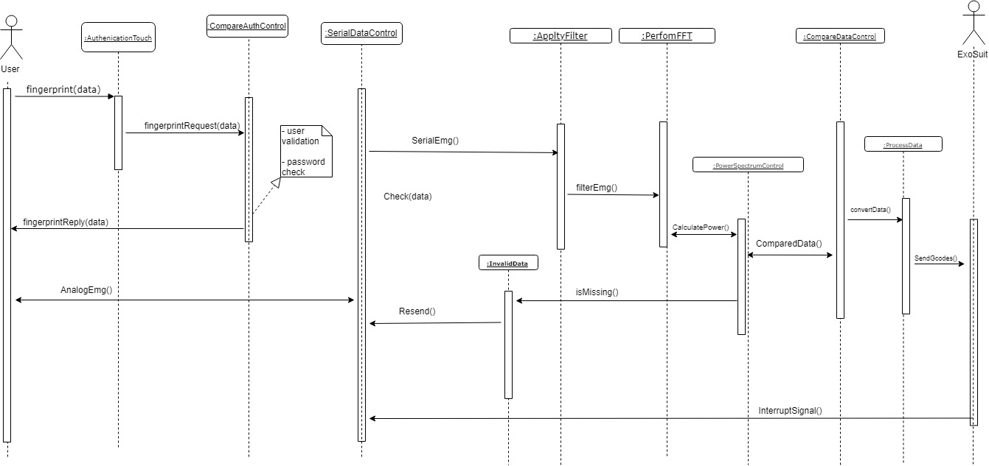

*Fig 3.6.3.1: Sequence Diagram*

* + - 1. **State machine diagram**

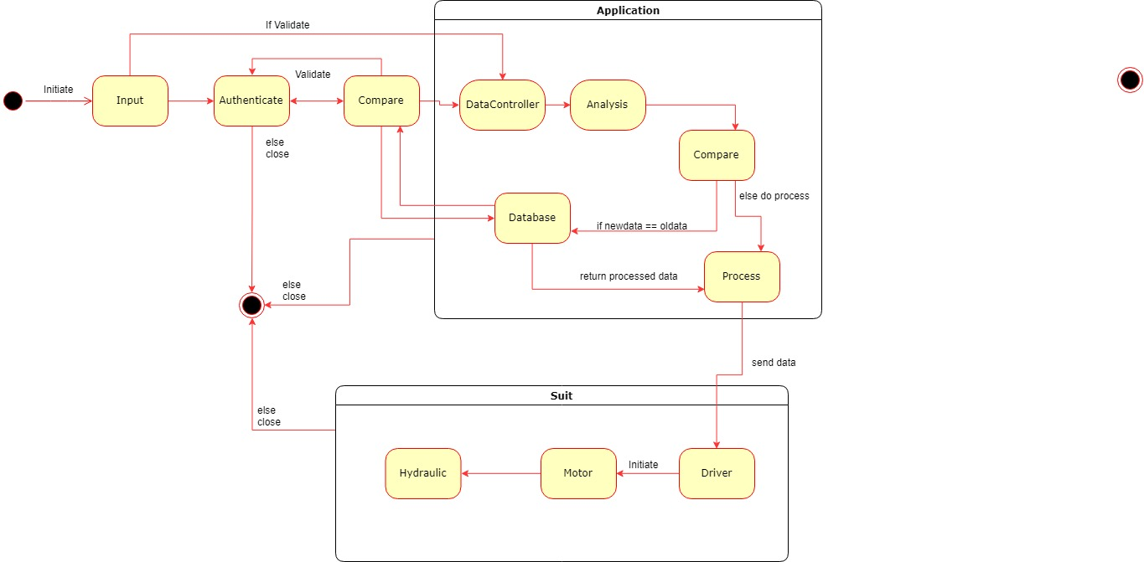

*Fig 3.6.3.2: State Diagram*

* + 1. **User interface with navigational paths and screen mock-ups**

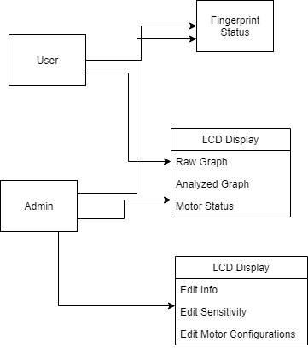

*Fig 3.6.3: UI with Navigation*

The system consists of two small displays. One display shows the finger print status either the user is authenticated or not. Another display shows all the signal and motor status. Both UI can be accessed by User. Admin can also access the configuration UI from which they can change user info, sensitivity and motor configurations.